Step 1
- Citrix Reciever(Small Window)
  - Check “Do not show again”
  - Click “ok”
Step 2
- Enter Email into the ZScaler(blue) window then click “Sign In”
- Use network logins then click “Sign In” (window should close)
Step 3
- Unpin the following applications from the Taskbar(bottom of the screen) by RIGHT clicking on the application then select “Unpin from TaskBar”
  - 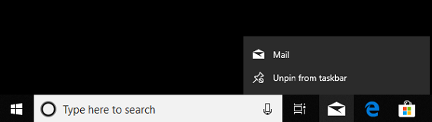
  - Microsoft Edge Microsoft Store Mail
    - 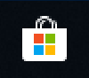
Step 4
- Using the Search bar at the bottom, search for the following applications. Once the application appears RIGHT click on the application then “Pin to Taskbar”
    - 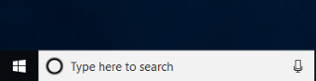
  - Part 1 – Search Internet Explorer – Once results populate, RIGHT click on the application then click on “Pin to Taskbar”
    - 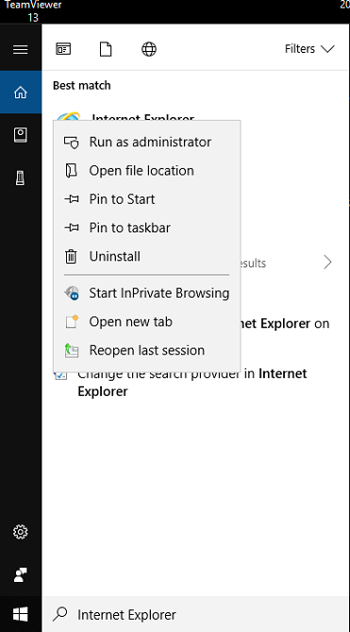

    - Launch Internet Explorer
    - Click “Recommended Settings”
    - Close second open tab
    - In the Address Bar type in the following
      - //sharepoint/default.aspx
    - Using the settings button(Little Gear) in the top right corner navigate to “Internet Options”
      - Click “Use current”
        - 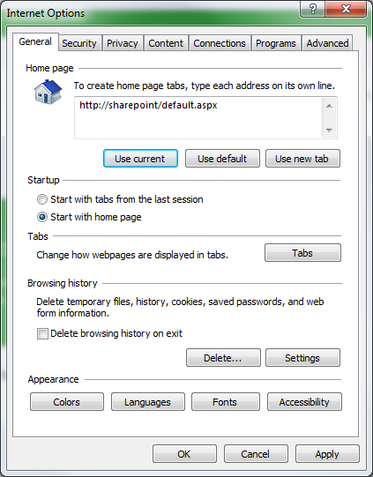
        - Click “Apply” then “OK”
        - Chrome and Edge have similar setup steps if preferred.

  - Part 2 – Outlook – Once results populate, RIGHT click on the application then click on “Pin to Taskbar”
    - 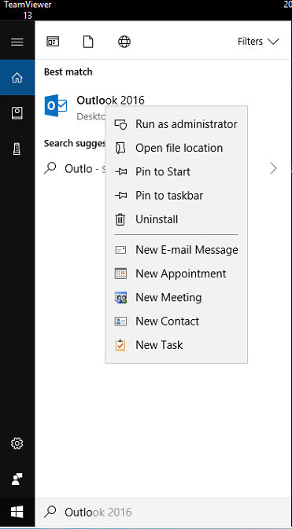
    - Proceed through the steps to finish. It may take a couple of minutes to update all Outlook folders.
    - To add a printer, please refer to the How to Add a Printer document in Tips and Solutions on the Zendesk page.

