Changing Default PDF to Adobe

- Click Start
- Search for and select “Default App settings”
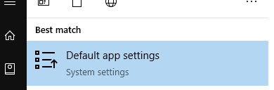
- Select “Choose Default Apps by file type”
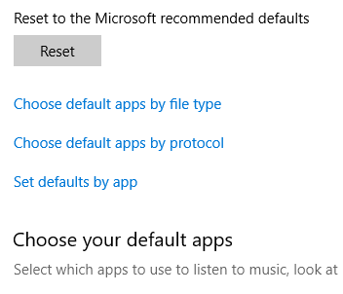
- Scroll down to .pdf
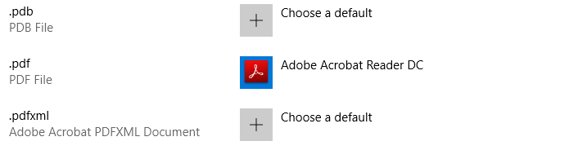
- Click on the Icon and change it to Adobe Acrobat
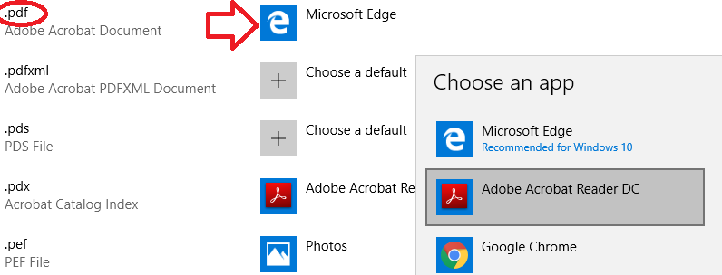
- Select “Switch Anyway” if required.
- Close out of Settings.

